Jewel Rhose Torio BSIT301 TP – HCI August 6, 2019

WEBPAGE (PUBG)

GUIDELINES:

As I design this webpage there are guidelines need to follow for this design to standout. As I design to create webpage the principles of design become very important. They are the devices that you need to use and will unknowingly use, since they make my webpage look nicer and become more visually appealing to people who are looking at.

**General HCI Design:** As it is a game webpage design in general I input most of important details of the game that people get interested on what is this game works, and as I design it color combination, images, icons are minimal but clear and effective so that the user don’t get confuse.

**User Type:** Considering the users; I assumed who are actually wanted to visit the webpage and mostly students/teens. So that design is modern and easy to understand and the webpage itself is interactive.

PRINCIPLES:

Upon creating a webpage design there are some basic principles that lie at the core of visual design. These principles are key in creating an effectively designed piece of artwork.

**Know the user:** My target user here are teenagers who loves online games (TPP/FPP). Webpage features a lot about the game yet leaves the user to their interest to the game.

**Understand the task:** The webpage is specific for game resource featuring the new updates, stories, other information.

**Reduce memory load:** Webpage design also keeping the number of choices/menus to maintain good awareness of on going task.

A good way out of creating an webpage design is learn and use guidelines and principles.

**HOME PAGE**



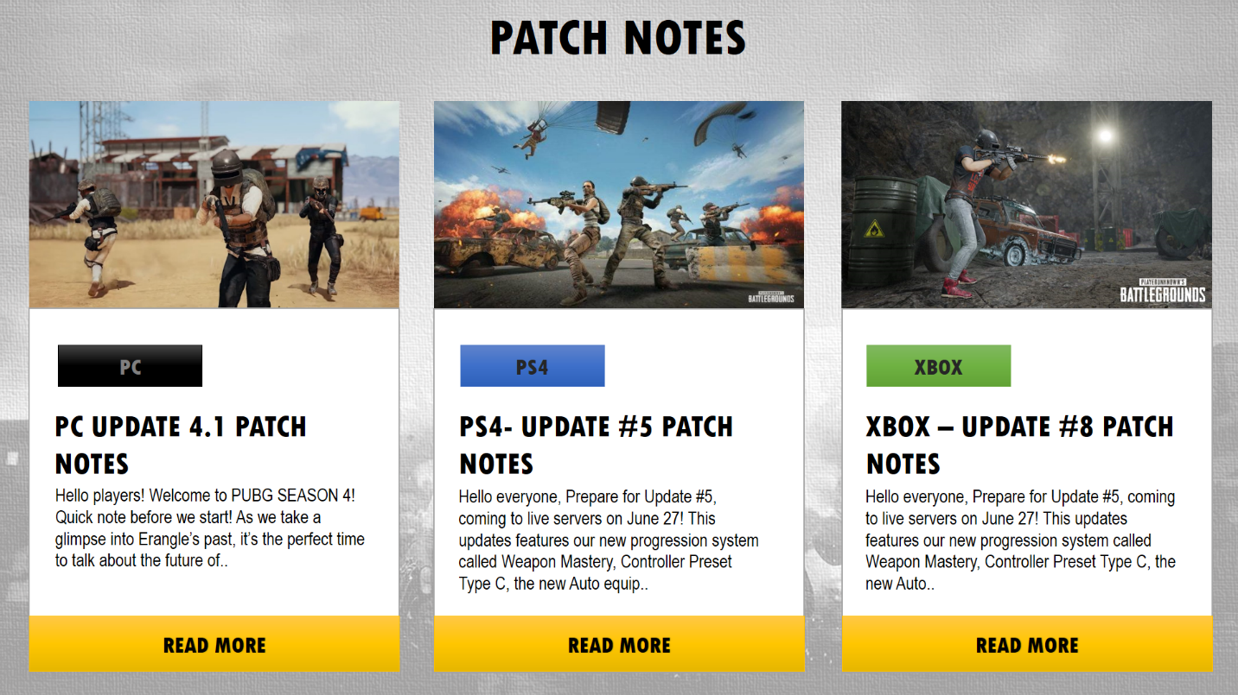

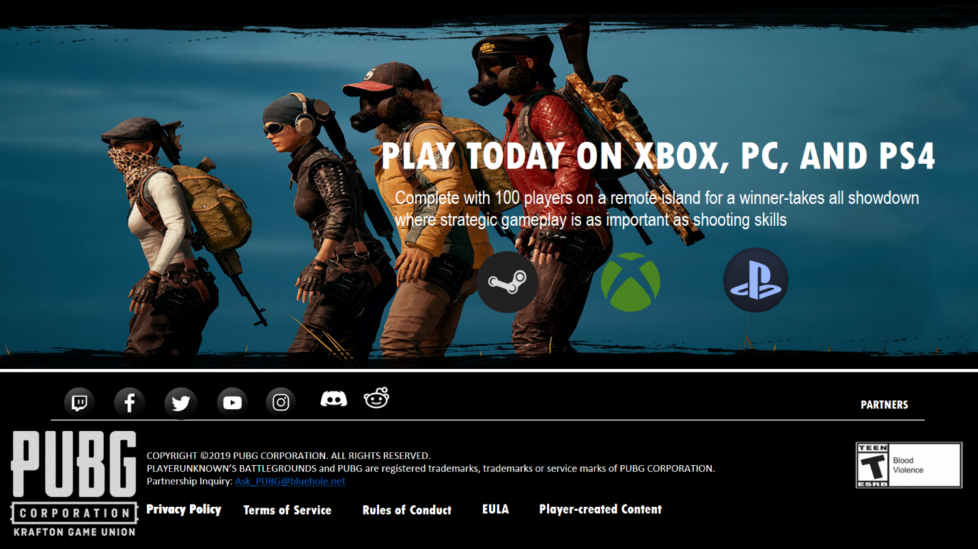

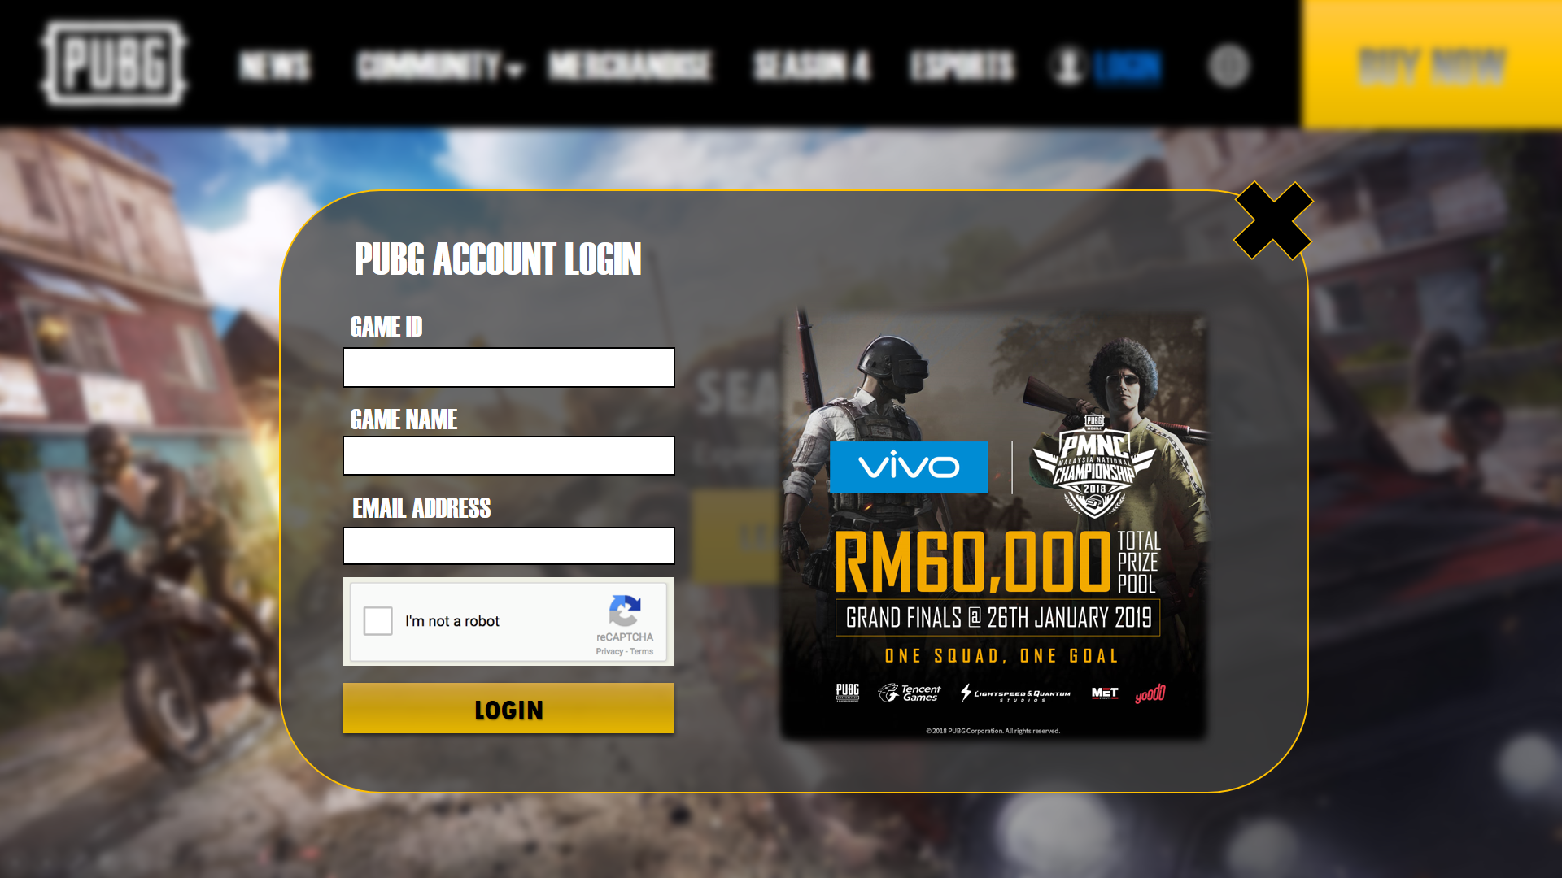**LOG-IN FORM**

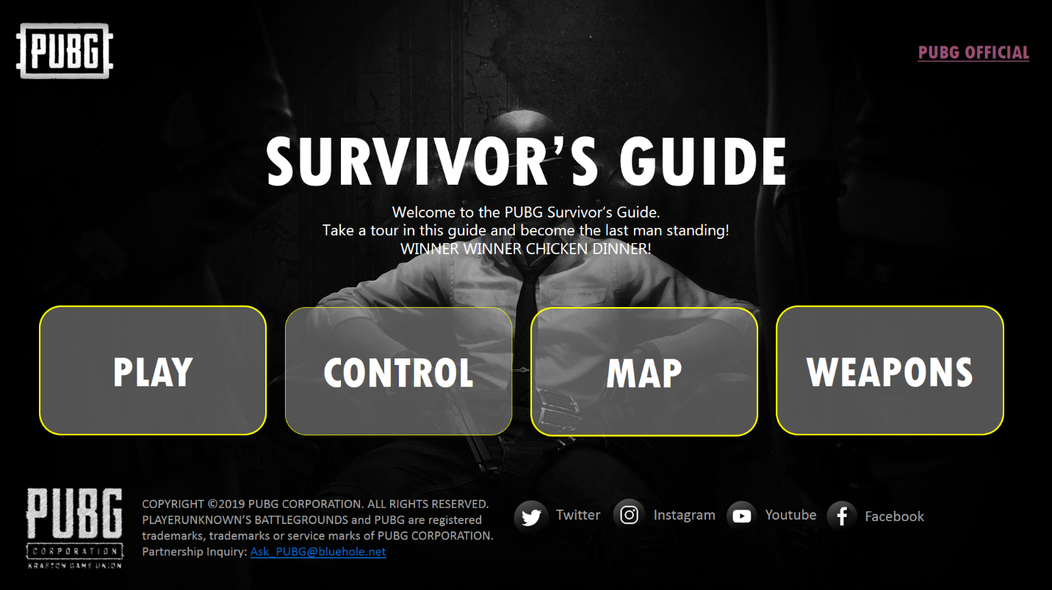**GUIDE / TUTORIAL**